aic
MRI-accredited by the American College of Radiology

ADVANCED IMAGING CENTER
PHYSICIAN NEWS
August 15, 2005
www.aicValencia.com

MR ARTHROGRAPHY

Q. What is an MR Arthrogram?

A. MR arthrography is a combination of Magnetic Resonance Imaging (MRI) and fluoroscopic-guided arthrography for the evaluation of joint abnormalities.

Q. What MRI techniques are utilized in MR Arthrography?

A. Diluted gadolinium is injected into the joint under fluoroscopic or CT guidance, similar to an x-ray arthrogram. After injection of Gadolinium contrast into the joint space, post-contrast fat saturation sequences are utilized causing the injected dye to be white against dark bone edges providing maximum tissue contrast.

Q. What are some key applications?

A. Knee: Evaluation of the menisci for recurrent tears after partial meniscectomy. Routine MRI may not be able to differentiate between post-surgical changes and a recurrent tear.
Shoulder: Evaluation of the glenoid labrum for a tear or SLAP lesion as well as post-surgical evaluation of the rotator cuff.
Wrist: Evaluation of the triangular fibrocartilage complex and scapholunate ligament for possible tears.

Q. Is MR Arthrography done at AIC?

A. Yes! We have been performing MR arthrograms for some time now on the new high-resolution GE Signa Ovation Excite Open-Sided MRI scanner. This procedure has allowed diagnosis of subtle joint abnormalities not obvious on routine MR imaging.
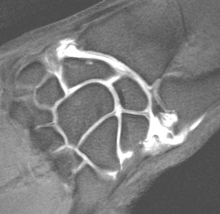
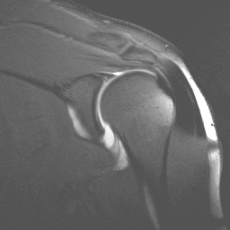

Three examples of joints imaged with MR arthrography: a wrist MR arthrogram (left) showing a tear of the triangular fibrocartilage complex (TFCC), a knee MR arthrogram (middle) with contrast in the joint, and a shoulder MR arthrogram (right) showing disruption of the inferior glenohumeral ligament-labral complex.

For more information regarding the above or any other questions, please call me at (661) 255-0060.

Ray Hashemi, MD
Ray H. Hashemi, M.D., Ph.D.
Director

